Banner 9 Self-Service Course Registration
Access Banner 9 Self-Service Registration via the Registration Menu page in self-service
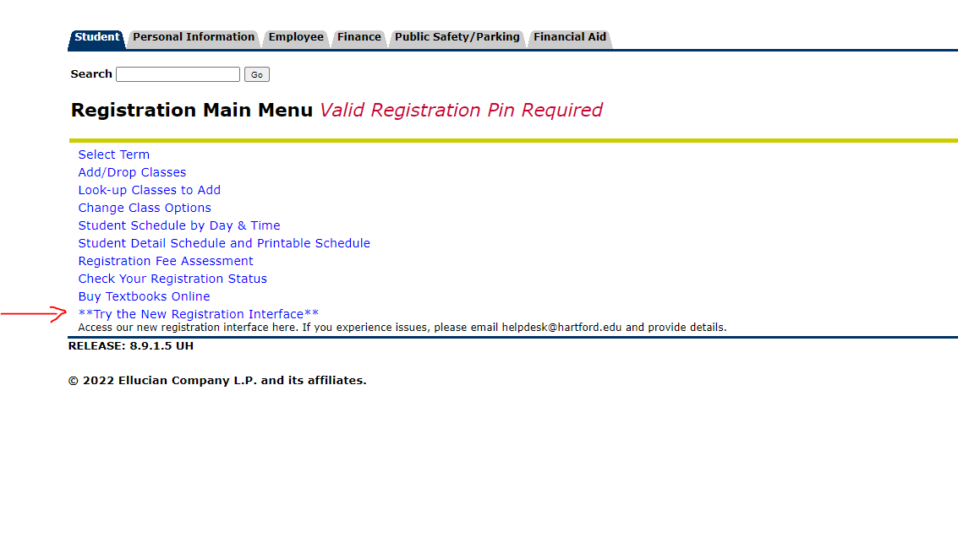
Banner 9 Self-Service Registration Landing Page
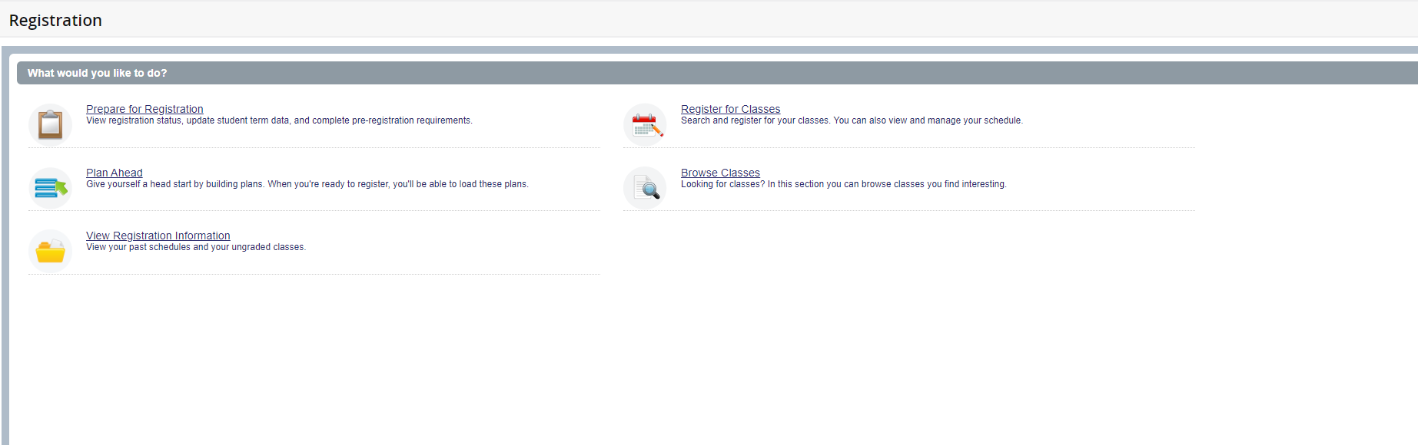
Action Item Processing
Prior to registering, you’ll need to accept the financial terms and confirm your personal information. Click the Continue button to complete both items. You cannot register using Banner 9 Self-Service registration without completing these tasks first.
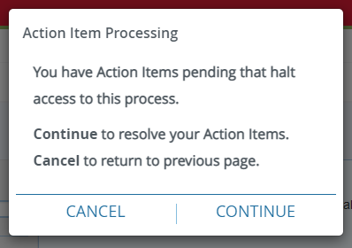
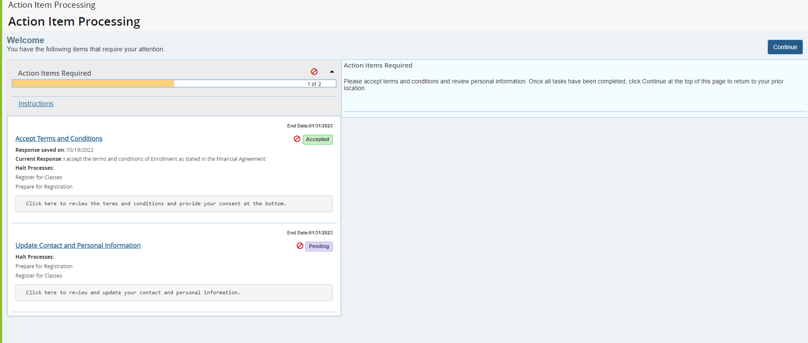
Click the blue Continue button to return to the Registration menu.

Prepare for Registration
Click on the Prepare for Registration link on the landing page to make sure you don’t have any holds that would impact your ability to register.
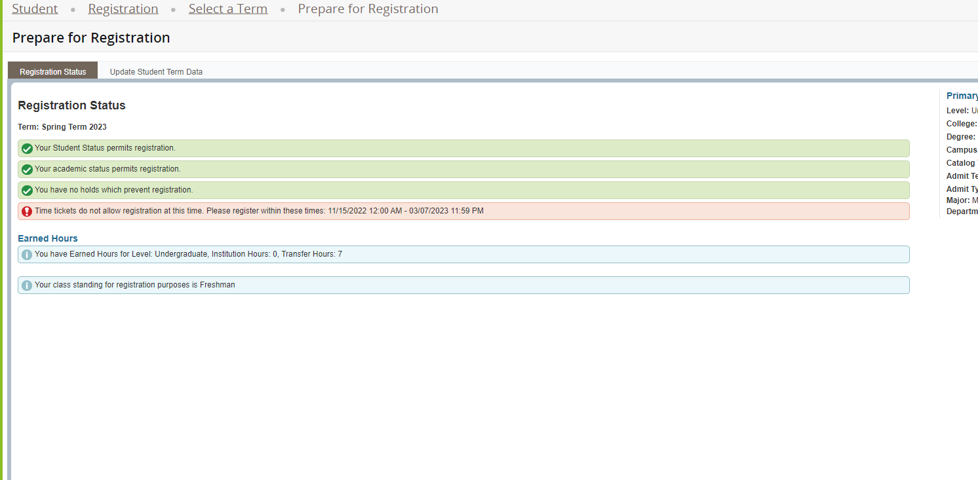

Plan Ahead
You have the ability to create a schedule plan ahead of your registration time. Plan ahead will open a few weeks before registration. You can have a total of 2 registration plans for any semester. Please note, courses saved in the Plan Ahead tool are not officially added to you schedule until you complete the registration process starting at your assigned registration time. To start creating your plan select the Plan Ahead link from the landing page. Select the term and Create New Plan. Use the search options along with the View Sections function to select sections to add to your plan. Plans can only be added to registration directly if you select specific sections/CRNs. If you only add course subjects/numbers to your plan (not CRNs) you will need to select specific sections during your registration time. Once you have added your courses make sure to select Save Plan and then enter a name for this plan. See additional information below on how to use the search options under the Find Classes feature.
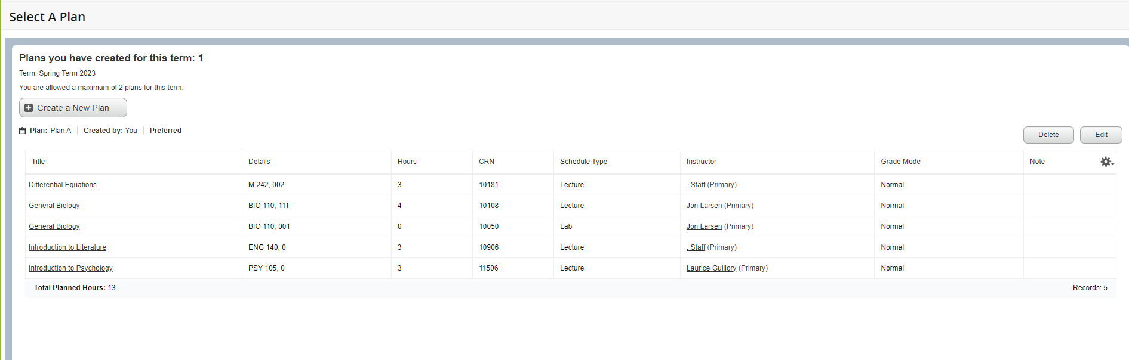

Register for classes
Select the correct term and if prompted, enter the Alternate Registration PIN you received from your academic advisor. Hit Continue.
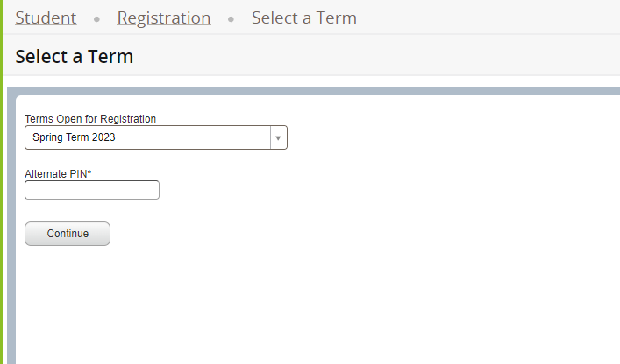

You can search for classes to add via the standard and advanced search features on the Find Classes tab or you can enter CRNs directly under Enter CRNs. You can also register by selecting one of your pre-populated plans on the Plans tab.

Additional information for using the Find Classes search feature: Basic searching can be done by selecting one or more subjects from the dropdown list and/or by entering the 3 or 4-digit course number. You can also search using keywords from the course subject, title and description. If you prefer searching for courses using the abbreviations, like CS110, you can enter those in the Subject and Course Number area. Advanced searching allows you to search by instructors, attributes, days/times and other search criteria. The dropdown lists will populate once you click on the specific search box. For example, if you click on Subject an alphabetical listing of the available subject descriptions will be shown starting with Academic Strategies - Hillyer. You can select additional subjects by clicking on the subject box and adding new subjects as desired. Courses from all selected subjects will be displayed.

Search for classes to add using class search
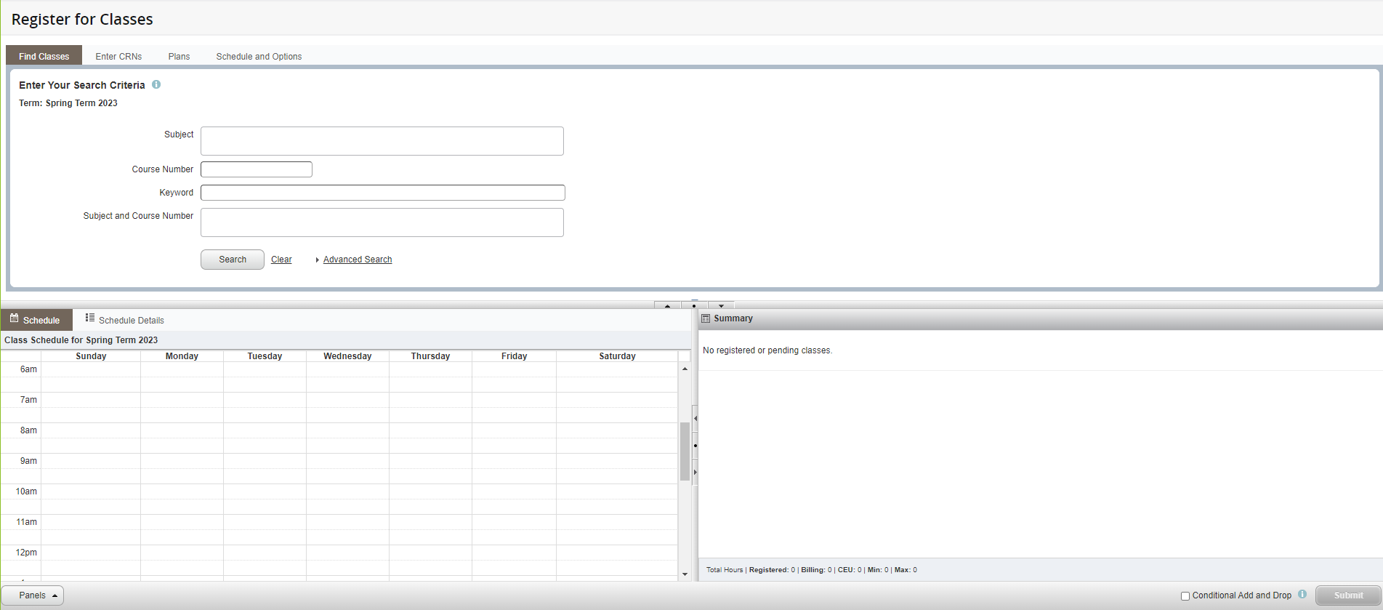

Add classes by entering CRN(s)
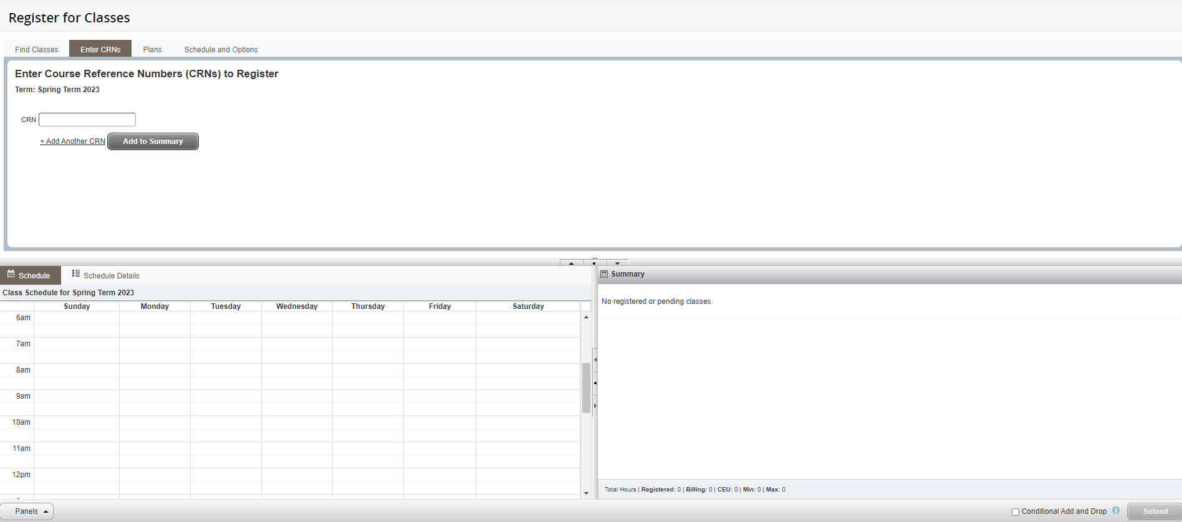

Add classes from a saved plan
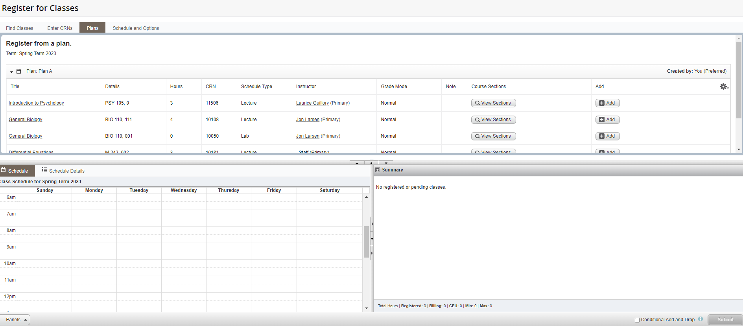

Once you add the courses to your registration they will be listed as Pending. You need to submit the courses to be officially registered. Status on courses that were successfully added will change from Pending to Registered. The calendar view will change from greyed out to color. The Schedule and Options tab will show your registered courses in both the list and calendar views. Courses that are variable credit can be adjusted under the Schedule and Options tab.
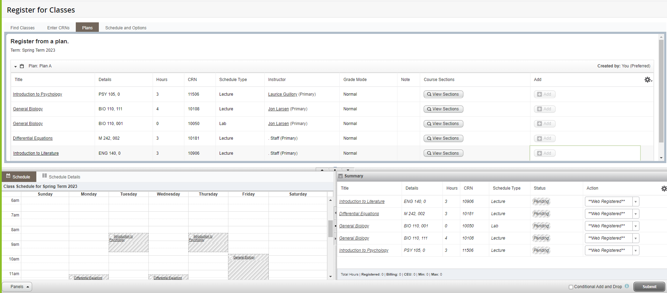
Courses are still pending. Not yet registered for courses.

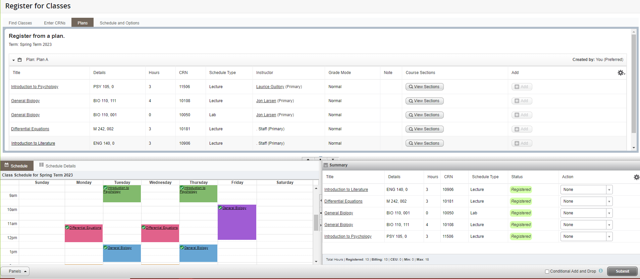
Registration successful for these courses.

If you check Conditional Add and Drop, courses will only be removed if a new course is successfully added during the same submission. Note in the example below, the student is trying to add MBA985 and drop M242. There were course restrictions on MBA985 that prevented successful registration for that course. Since conditional add and drop was checked no registered course was removed.

